加强英文摘要以及英文目次图文摘要的
说明与示例
为了使国外同行更好地了解您的论文，从2018年起，我刊将要求所录用稿件
加强英文摘要的内容，并且在英文目次中增加图文摘要，具体格式请参照网站“期刊动态”中的“说明与示例”，请作者予以配合。
１．英文摘要的内容比中文摘要更为详尽充实，除了研究方法、结果与结论外，英文摘要还应简要叙述课题的研究背景、目的和意义，拥有与论文同等量的主要信息，英文摘要的单词数为250～300个，约占半页版面。
２．英文目次要列出图文摘要，请挑选1～2副能体现论文创新意义的彩图（可以用文中有代表性的图，也可另外作图），并简单介绍一下论文的亮点（50个单词左右）。

英文摘要示例：
Synthesis and Catalytic Properties of Silver Nanoparticles Prepared by Cyclodextrin in-situ Reduction Method
QIU Zhi-qiang, WANG Jie, YUAN Zhen-yu, SHI Yu-ling, GUO Xu-hong
(State-Key Laboratory of Chemical Engineering, East China University of Science and Technology, Shanghai 200237，China)
Abstract: Metal nanoparticles exhibited different physicochemical properties as compared to their bulk materials due to their high surface-to-volume ratio, which had a broad application prospect. However, the tendency of aggregation of nanoparticles must be overcome by using suitable capping agents. The capping agents played a significant role in stabilizing the metal nanoparticles and influenced their catalytic performance. Therefore, it’s necessary to find the proper capping agents of metal nanoparticles. A facile and effective method to produce silver nanoparticles (Ag-NPs) in a water solution is reported. Cyclodextrin (CD), a soluble nontoxic molecule, was made up of six, seven, or eight glucose units, called α-, β- and γ-CD, respectively. Due to their unique hydrophobic cavities, CDs were used as an eco-friendly capping agent to stabilize the Ag-NPs by the hydrophobic interactions with the apolar primary faces of CD. In this paper, CD-capped silver nanoparticles were synthesized in an alkaline aqueous solution by reducing silver nitrate with CD and the synergetic catalytic effect between Ag-NP and different kind of CDs was investigated. Then TEM, FT-IR and UV-vis spectroscopy were employed to characterize the synthesized Ag-NP. It was revealed that the size distributions of Ag-NP prepared in proper pH and CD concentration were quite uniform and could be controlled (10-30 nm). And a higher pH (pH>12) or lower CD concentration ( c<0.0025 mmol/L) would lead to the aggregation of Ag-NP during the synthesis procedure. Recently, it was reported that the CDs and Ag-NP had cooperative catalytic activity during the 4-nitrophenol (4-NP) reduction reactions. During the reaction, the CD-capped Ag-NP had a strong catalytic effect on the reduction of 4-NP, and it was found that β- and γ-CD-capped Ag-NP had a better catalytic activity than that of α-CD-capped Ag-NP. The activation energy of β-CD-capped Ag-NP in the reduction of 4-NP was calculated to be 48.1 kJ/mol, which is lower than that of α- and γ-CD-capped Ag-NP.
Keywords: cyclodextrin; silver nanoparticles; catalysis; 4-nitrophenol

英文目次中图文摘要示例：
Synthesis and Catalytic Properties of Silver Nanoparticles Prepared by Cyclodextrin in-situ Reduction Method
QIU Zhi-qiang, WANG Jie, YUAN Zhen-yu, SHI Yu-ling, GUO Xu-hong

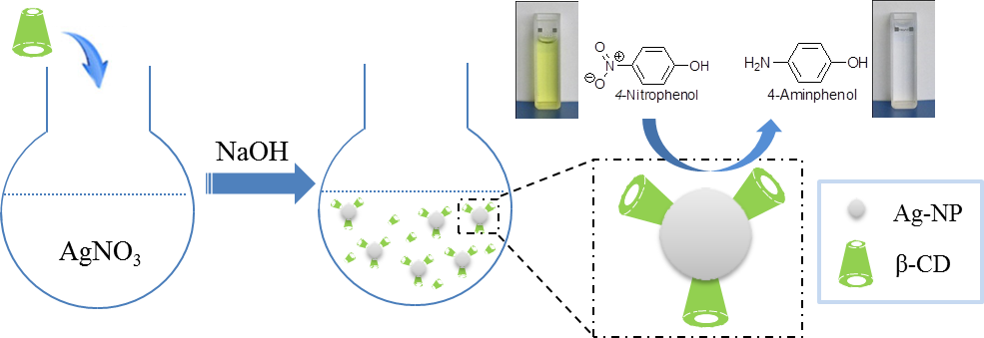

A facile and effective method to produce silver nanoparticles (Ag-NPs) in a water solution is reported. CD-capped silver nanoparticles were synthesized in an alkaline aqueous solution by reducing silver nitrate with CD. The synergetic catalytic effect between Ag-NP and different kinds of CDs was investigated.

